Scavenger Hunt Directions Worksheet
Your scavenger hunt is a group project to teach the class about your decade. This activity will let you know if your group has been successful in teaching the class about your topics.
You get to make up your own worksheet. You’ve seen enough of them in school, now it’s your turn.
Each person in the group will help type in their own questions and save them to their own flash drive. You will be turning in your information to the teacher individually and collectively.
You can add an image on the page if you want.
Open up a word document.
You will want to have a place for the students to put their names and date at the top of the page.
- Title your worksheet with your decade and your group names. (See example)
WELCOME TO THE 2OTH CENTURY
Explore the 1900’s with (Team 00 and list your first names)

- Next, you will want to give s short summary facts of what your decade was about. (example below).
  - Ask everyone in the group to contribute one fact to the introduction.
  - Notice how these students gave directions in the very beginning.
  - You do not have to center the information on the page.
  - Look carefully at your spelling and punctuation and sentence structure.
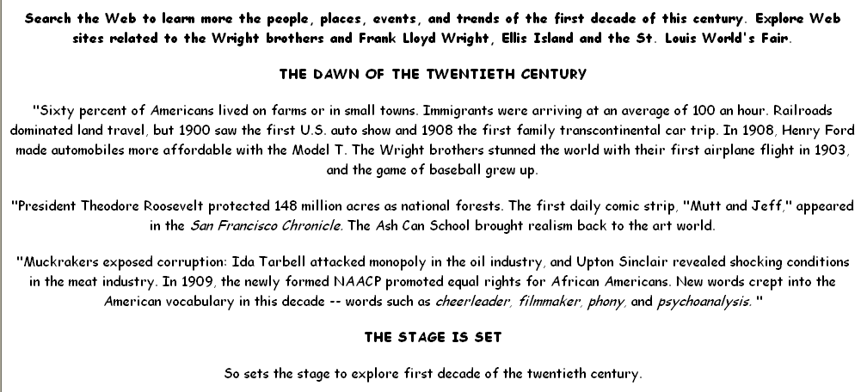

- You will now put your questions and the internet address where students will research their answer.
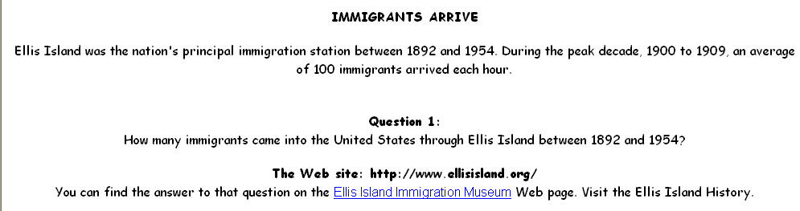

  - Remember to leave a space for the students to write their answers to the question.

- Each student in your group must contribute 3 statements, questions, and URL address for each of their research categories. (you can copy your statements and questions from your flash drive onto the leaders computer).

- After the worksheet is completed, save it to the leaders flash drive.

- Make up an answer key for the teacher.(typed or written)

- You will print 2 copies for the teacher (one for the teacher to make copies for the class and one for the answer key).

